Chapter 18, Solution 48.

Find i_{o}(t) in the op amp circuit of Fig. 18.50.

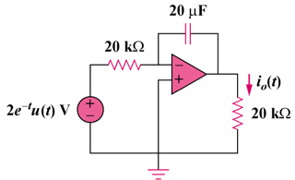

Figure 18.50
For Prob. 18.48.

Solution

0.2F

As an integrator,

i_{o}(t) =

